Mental Health Matters: it’s safe to talk about suicide
Suicide can occur in any family, any community. We know locally what a deep and confusing sorrow it can be when someone ends their life by suicide. It can be very difficult to talk about it but when we are ready, it can be helpful and healing too.
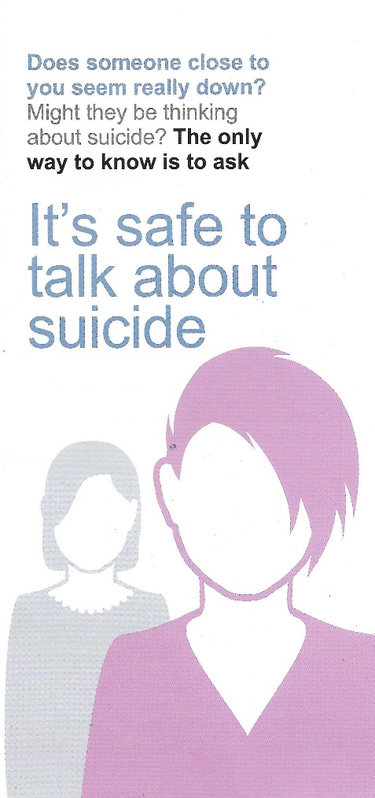
When people are feeling so despairing, so overwhelmed with sad feelings that they contemplate suicide it may be good for them to talk about it too. It’s important to ask as people who are feeling suicidal commonly feel cut off from everyone. Speaking with one another makes a connection, builds a bridge, opens opportunities for other options or possibilities. But we can feel worried about asking, fearing we’ll make things worse or find ourselves out of our depth.
There have been many studies seeking to understand what helps. These have found that saying something is safer than saying nothing and saying the word will not make it happen. Devon County Council have issued a helpful leaflet offering some ideas and guidance which can be accessed here www.devon.gov.uk/care-and-health/factsheet/suicide-prevention/
And do remember that the Samaritans are always willing, interested and available to listen … as it now says at the Hele crossing, call for free, anytime …
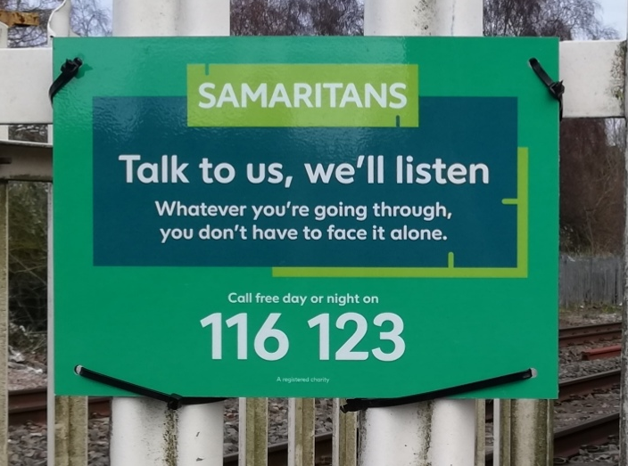

or email and get a reply from jo@samaritans.org within 24hrs. The Town Council and BradTog have also invited the suicide support charity ‘Pete’s Dragons’ to provide a 2hr online training opportunity to develop more understanding and confidence in speaking with people who may be struggling with despair. We’ll let you know soon how that will be offered.
Please make contact if you are interested in this or other mental health matters and wish to stay informed. mentalhealthmatters@bradninchtogether.co.uk
All good wishes
Glenn, Kate and Sophie
For BradTog MHM
Ps. Do let us know if you have suggestions or offers to make for future postings

