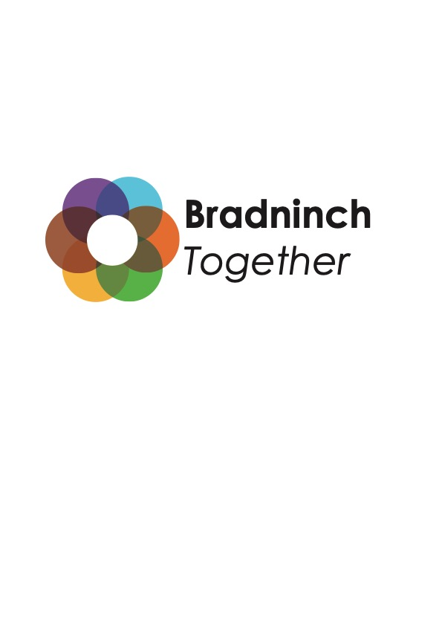

This could be completed with a BradTog Director

There are a simple set of questions which, when completed, will help us all know what a project is. They are on the reverse of this sheet.

We have also created a Project Guide which will be useful for project leaders and BradTog to consider when devising and agreeing something new. It’s a useful checklist of things to be considered when planning. It’s on the website www.bradninchtogether.org.uk

BradTog and its volunteer Directors seek to help projects, and whilst best advice and help will be given, BradTog cannot guarantee success or accept responsibility for resolving problems encountered, although we will assist with a positive spirit. Project decisions will be made by Project teams and their leader(s), which might or might not involve BradTog Directors.

The person(s) providing leadership for the project will be asked to contribute to BradTogs overall decision-making about all Bradtog activities; part of being one community.

BradTog will not claim ownership of a project or responsibility for its success.

BradTog will expect to be credited as a working partner using words such as ‘’In association with BradTog” as agreed appropriate in each case.

Bradtog Directors bringing forward a project will go through the same process as projects coming from outside the group.

Purpose: What is the ambition of the project and how might it be achieved?

Timing: What are the anticipated timeline and milestones reached getting there?

Request: What does the project anticipate needing from BradTog?

Leadership: Who will take on this role, and liaise with BradTog?

Finances: Is there a financial aspect and how will this be handled?

Risk awareness and safety planning: What risks are associated with this project and what are any mitigation plans?

The Bradtog Director(s) liaising with the project is/are………………………..

This Project was discussed by the following people on the following date:

Further actions:

